Biography – Dr. S. Ganesh, M.E., Ph.D.

HoD/EEE

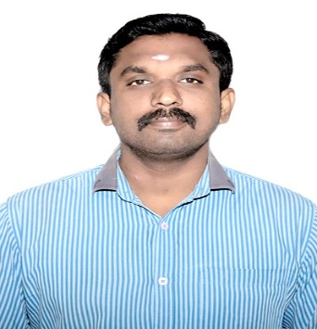
Dr. S. Ganesh, M.E., Ph.D. (Electrical) is an experienced academician, researcher, mentor, and engineering professional with 12 years and 5 months of experience in teaching, research, innovation, and academic development. He is currently serving as HoD/EEE and Associate Professor at Grace College of Engineering, Thoothukudi. He completed his B.E. in Electrical and Electronics Engineering, M.E. in Power Systems, and Ph.D. in Electrical Engineering from institutions affiliated with Anna University.
His major research areas include Power Systems, Distribution System Reconfiguration, Renewable Energy, Microgrids, Smart Grids, Energy Storage Systems, D-STATCOM, Electric Vehicles, Artificial Intelligence, IoT, Cybersecurity, and Cyber-Physical Systems. He has contributed 22 journal publications, including publications in Scientific Reports, Wiley, IET, IEEE and other Scopus-indexed journals, along with 2 Scopus-indexed book chapters.
Dr. Ganesh has presented 25 research papers in national and international conferences on emerging areas of electrical engineering, AI, renewable energy, microgrids, smart grids, IoT, energy storage, and power-system optimization. He has also served as a reviewer for 4 international journals published by IEEE, IET, Wiley and Taylor & Francis.
He has 3 patents in the areas of variable-frequency-drive technology, multi-agent robotic systems, and microgrid power scheduling. He has successfully contributed to funded research and innovation projects, including an AI-Powered Cyber Security for Smart Cities and Industrial Control System project supported by AICTE with funding of ₹3,50,000.
He is also actively involved in student innovation and project mentoring. As a mentor, he has guided student projects that emerged as Niral Thiruvizha winners, including the Hybrid Microbial Fuel Cell and Solar Powered E-Bicycle project under Naan Mudhalvan–Niral Thiruvizha. The project received support under the programme, with the resume recording ₹10,000 funding. Another one of the innovative projects is “VR for Engineering Education,” focusing on the application of Virtual Reality for immersive and effective engineering learning. The projects received ₹15,000 funding support under Niral Thiruvizha.
In addition, he has contributed to industry-supported student skill development and innovation activities, including ICT Academy–CSR funding of ₹25,000, supporting student-oriented technical and innovation initiatives.
Dr. Ganesh has organized 22 academic programmes, including FDPs, international conferences, workshops, webinars, hackathons, technical training programmes, and innovation events. He has participated in 69 workshops/webinars, 17 Faculty Development Programmes, and 19 certification courses, covering renewable energy, AI, machine learning, smart grids, IoT, electrical engineering, research methodology, innovation, and emerging technologies

